Curriculum Vitae

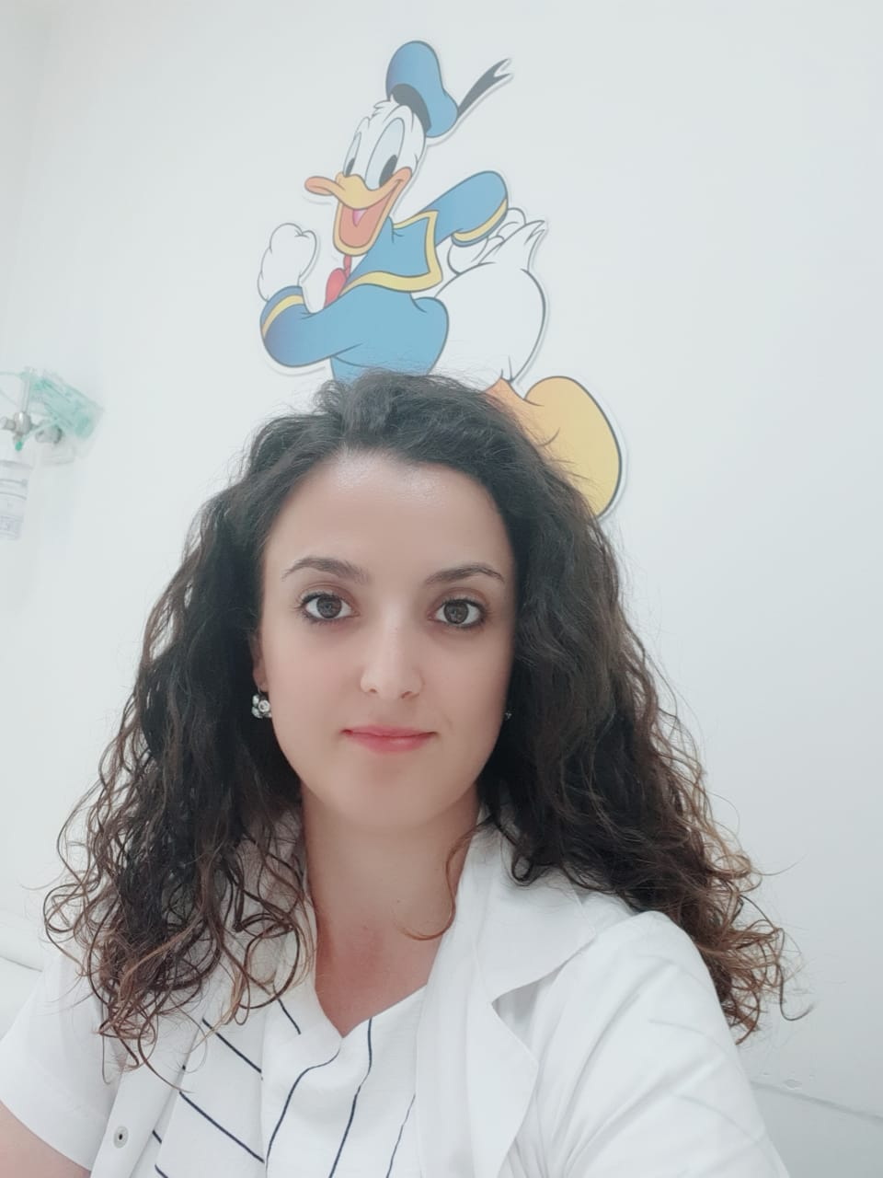

Dr. Blerina Gjoni

Specialiteti: Pediatër Infeksionist
Titulli: Mjek
Ushtron aktivitetin prej vitit: 2015
Punon pranë: Shëbimi i Pediatrisë Infektive
PAI …Pediatri
QSU “Nënë Tereza”
Rruga e Dibrës, Nr. 372, Tiranë

Eksperienca ne pune:

30 Korrik- 30 Nentor 2010
Institucioni Qendra Spitalore Universitare Nene TEREZA

Funktioni Mjek I pergjithshem

Dhjetor 2010 - Prill 2011:
Institucioni: Qendra shendetesore“ Poliklinika Nr 4,Tirane’ )
Funktioni: Mjek I pergjithshem

Prill 2011 – Prill 2015:
Institucioni: Qendra Spitalore Universitare Nene TEREZA

Funksioni: Specializim ne PEDIATRI
.

Prill 2015-Dhjetor 2019 Mjek Pediater ne Urgjencen Pediatrike,QSUT

Dhjetor 2019 e ne vazhdim Mjek Pediater ne Pediatri INFEKTIVE,QSUT

EDUKIMI:

2011-2015 SPECIALIZIMI NE PEDIATRI,QSUT

2004-2010 UNIVERSITETI I TIRANES

TRAJNIME

23 Gusht- 28 Gusht 2004
International Seminar for cystic fibrosis in children, organized by Cystic Fibrosis Center of the Necker Enfant Malades Paris Hospital, organized in Corfu of Greece

Qershor 2006 Training Course on HIV / AIDS organized by the Swiss Foundation “ Partnership in health” .

Nentor -Dhjetor 2005
Shkurt 2006 Trajnim me temen "Prevention of torture"
Maj – Qershor 2006 and "Mental Health and the Human Rights" organized by the Albanian Center for rehabilitation of trauma and torture

10-12 Mars 2010 Trajnim ne“ Capacity-Building on Gender and Health” organised by Ministry of Health and World Health Organization.
Tetor 2017 Trajnim in Bambino Gesu Ospedale PEDIATRICO:Malattie inflamatorie in pediatria confronti clinici al letto del malato
Maj 2017 Pjesemarrje ne “The research unit and development and production facilities by FREZEDERM”
Gusht 2018 Pjesemarrje ne Humana HCP Event

